**Streaming Dynamic Content using Amazon CloudFront**

Pham Huu Hung – 102643407

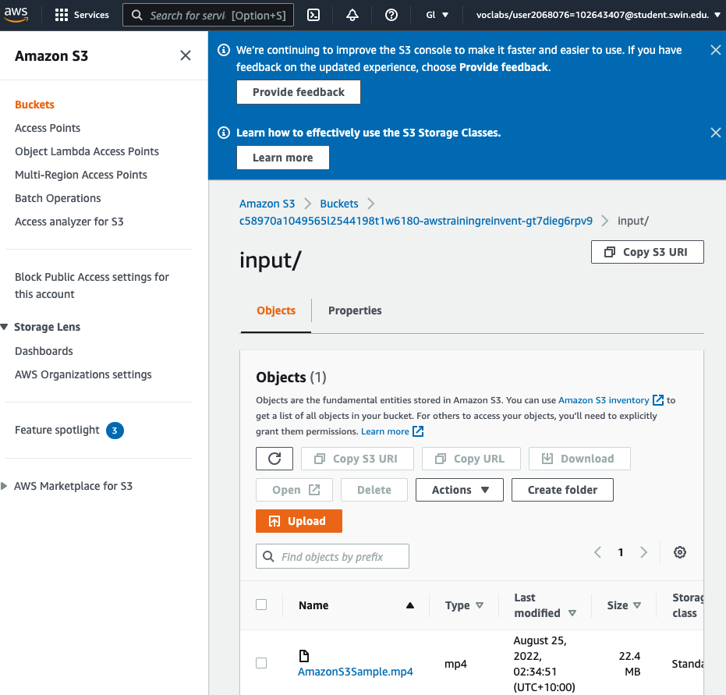

Checking preparation: S3 bucket is available, and file AmazonS3Sample.mp4 is inside input folder.

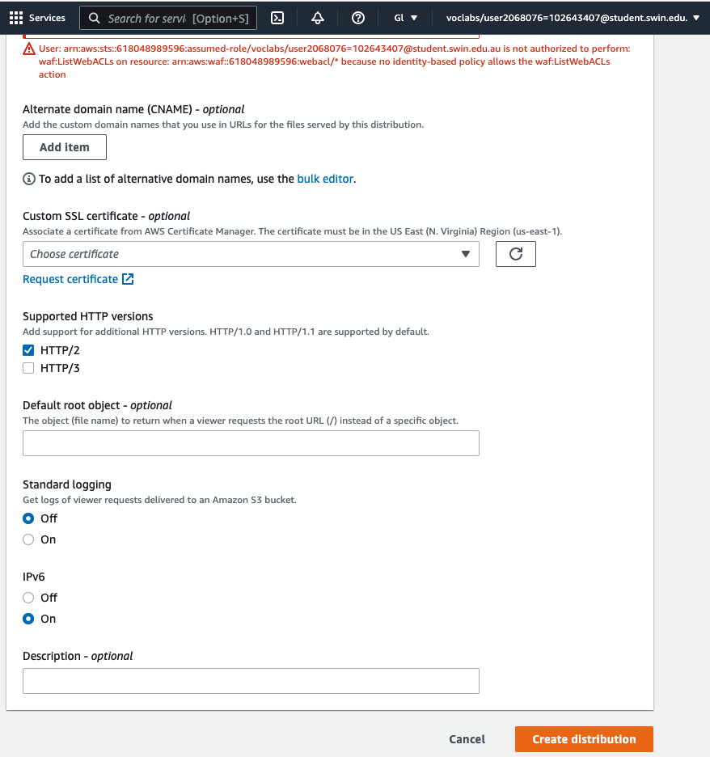

Configure and create distribution

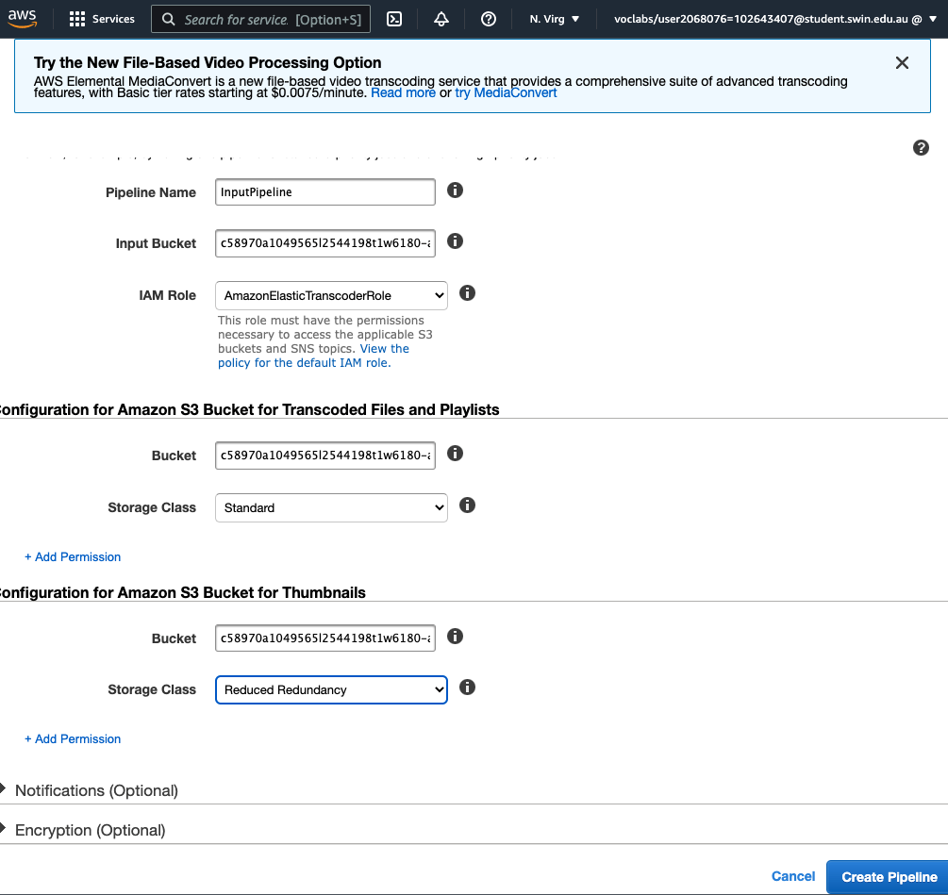

Configure and create pipeline

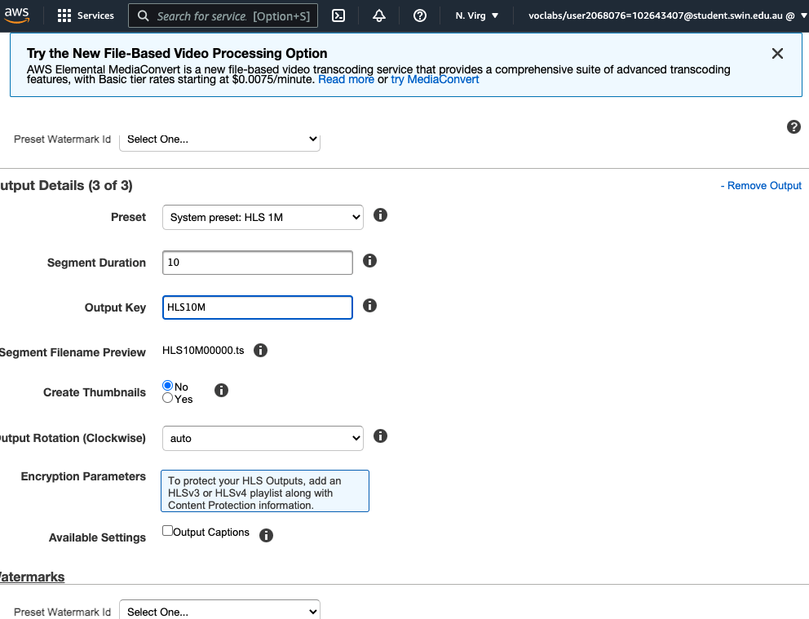

Configure three output files having three separate bit-rates (2Mpbs, 1.5 and 1)

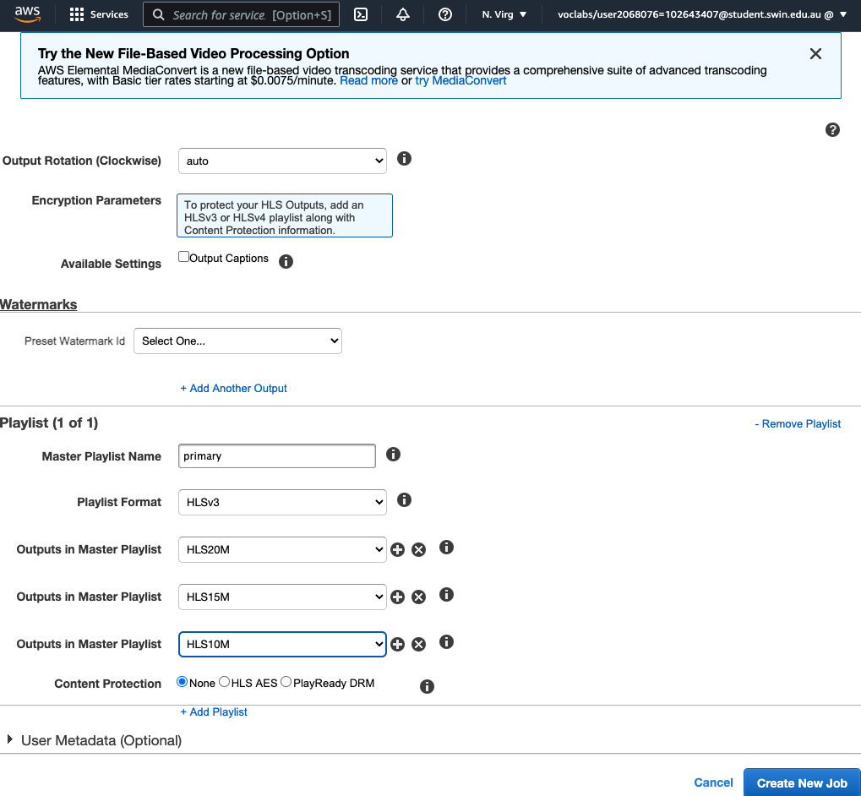

Configuring playlist and create new job.

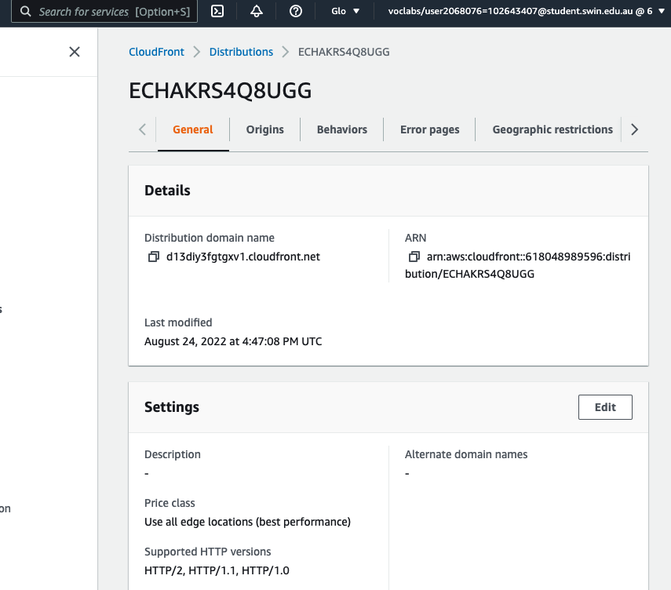

Copy the cloudFront domain name to construct playback url

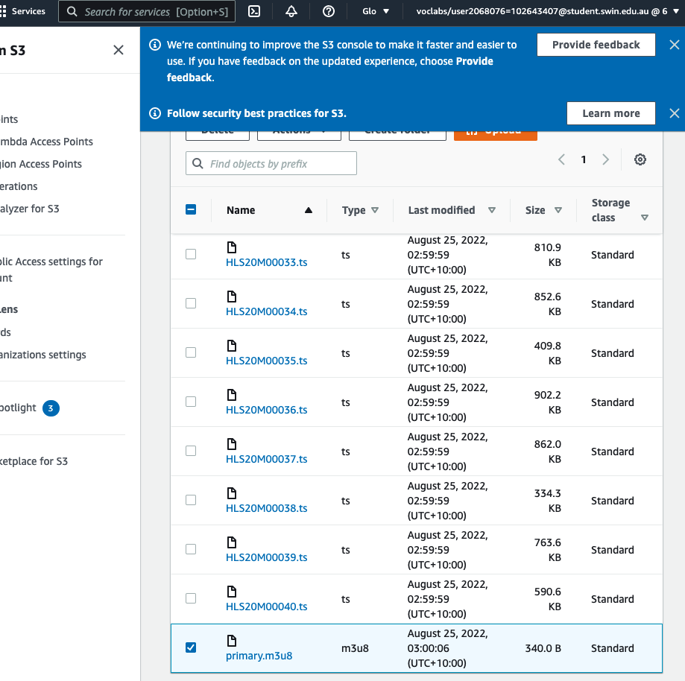

Construct the rest of the url by adding path of the playlist file in the S3 bucket.

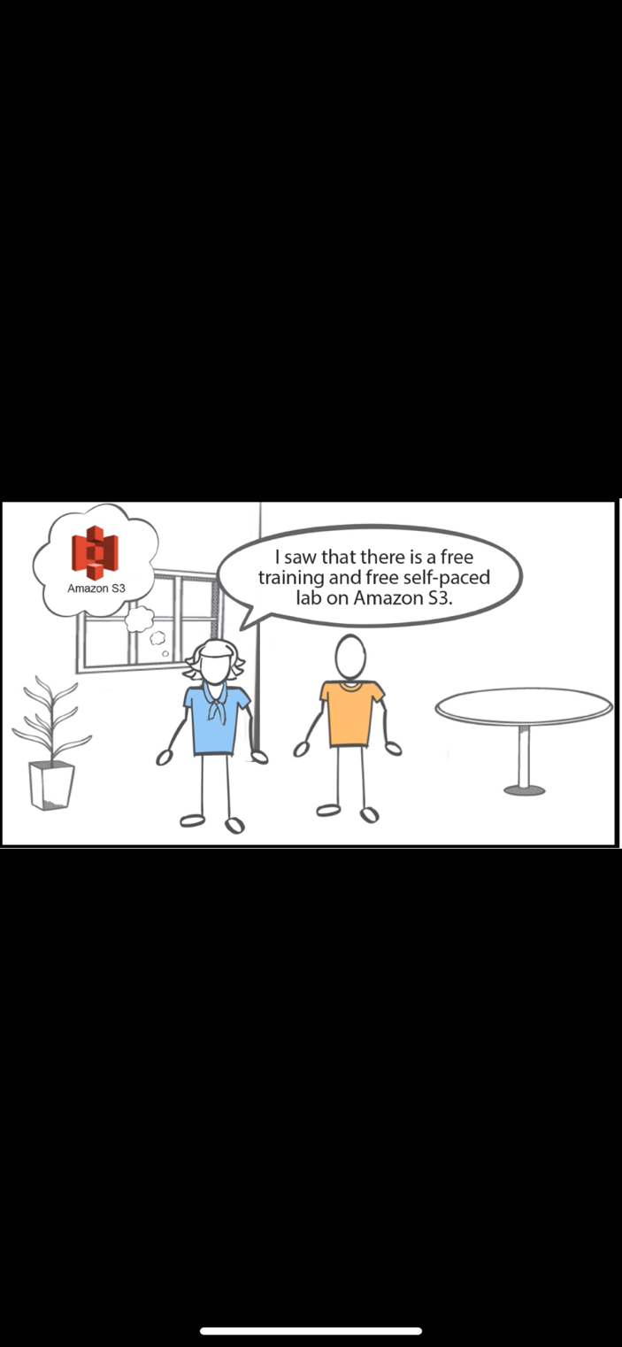

Successfully start the stream on iphone.

Successfully submit the lab